**Database-First Approach Of Entity Framework In Asp.Net Mvc 5**

* In the database-first approach the Entity Framework creates model classes and properties corresponding to the existing database objects, such as tables and columns.
* The database-first approach is applicable in scenario where a database already exists for the application.

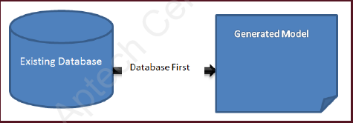Following figure shows the database-first approach: